
September 25, 2025
NOTICE OF PUBLIC HEARING
Notice is hereby given that a Public Hearing will be held in the Oak Bay Municipal Hall Council Chambers located at 2167 Oak Bay Avenue, Victoria, BC, on Wednesday October 8, 2025, at 6:00 p.m. to allow the public to make verbal or written representations to Council with respect to the following proposed bylaws for the property located at 1950 Lansdowne Road / 3100 Foul Bay Road (Camosun College) :

- OFFICIAL COMMUNITY PLAN AMENDMENT APPLICATION – OCP00011 and REZONING APPLICATION – ZON00059 – 1950 Lansdowne Road / 3100 Foul Bay Road (Camosun College)

Official Community Plan Bylaw No. 4620, 2014, Amendment Bylaw No. 4925, 2025
This bylaw proposes to amend the OCP Land Use Designations table in order to allow the development of a 6-storey, 429 bed student housing facility.

Zoning Bylaw No. 3531,1986, Amendment Bylaw No. 4926, 2025
This bylaw proposes to amend the P-1 General Institutional Zone in order to allow the development of a 6-storey, 429 bed student housing facility, and future institutional uses associated with Camosun College.

1950 Lansdowne Road/3100 Foul Bay Road (Camosun College)
Lot 1, Section 31, Victoria District, Plan EPP147445; PID 032-617-267

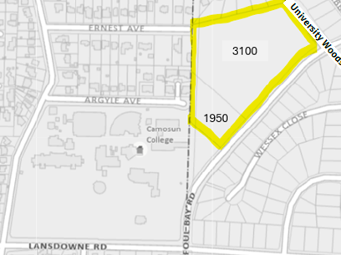

HOW TO PARTICIPATE:
- Watch the Public Hearing online: https://oakbay.civicweb.net/Portal/MeetingTypeList.aspx

- Attend the Public Hearing in Person:
Council Chambers, 2167 Oak Bay Avenue, Victoria, BC

- Attend online via Zoom:
To participate via Zoom using a computer, smart device or telephone use the meeting ID and password or the toll free number located below.
Toll-Free: 1-855-703-8985
*9 to raise your hand
*6 to unmute
Meeting ID: 856 4956 6097
Passcode: 604222

- Submit written comments:
Written comments must be received by the District of Oak Bay no later than 2:00 p.m. on October 8, 2025, in order to be placed before Council for consideration. Written submissions can be delivered to the District by:
Drop Box: Main Door - Oak Bay Municipal Hall - 2167 Oak Bay Avenue
Email: planning@oakbay.ca
Mail: District of Oak Bay - 2167 Oak Bay Avenue - Victoria, BC V8R 1G2

Please note: Any correspondence received and intended to be considered by Oak Bay Council during meeting deliberations will form part of the public record and will be published on the agenda when the matter is before Council. The District considers your address relevant to this matter and will disclose this information, as it informs Council’s consideration of your opinion in relation to the subject property and is authorized under section 26(c) of the FOIPPA Act. Your email and telephone number will not be disclosed. For more information on the FOIPPA Act please email foi@oakbay.ca.





How to view the proposed bylaws and information about these applications:
- In person at the Oak Bay Municipal Hall between the hours of 8:30 a.m. and 4:30 p.m., Monday through Friday, except holidays
- By requesting a copy of the bylaws by emailing the Community Building and Planning Department at planning@oakbay.ca
- Development Tracker: https://www.oakbay.ca/municipal- services/planning/development-application-tracker (1950 Lansdowne Road / 3100 Foul Bay Road (Camosun College)
- Public Hearing agenda: Available the Wednesday before the Public Hearing, in person at Municipal Hall, or on the District website: oakbay.civicweb.net

